Health Cloud Data Model
Contents
Executive Summary 2
Introduction 3
A Patient’s Healthcare Journey 3
Person Records for Patients and Members 4
The Household Data Model 4
Clinical Data Model 6
Clinical Encounters 6
Diagnosis and Medications 9
The Health Insurance and Claims Data Model 10
Member Plans 12
Claims 13
The Care Program Data Model 15
Care Program Enrolments and Goals 15
Care Program Products 17
Care Program Campaigns and Surveys 18
Social Determinants of Health Data Model 19
Care Determinants 19
Care Barriers 19
Care Interventions 20
The Provider Data Model 21
Healthcare Providers 22
People 22
Organizations 22
Healthcare Facilities and Facility Practitioners 22
Healthcare Facilities 22
Healthcare Practitioner Facilities 23
Healthcare Payer and Facility Networks 24
Healthcare Provider Specialties 25
Healthcare Provider Certification, Education, and Licenses 27
Utilization Management Data Model 28
Care Requests 29

Executive Summary
Salesforce Health Cloud provides a connected data foundation for managing a patient or member’s end-to-end healthcare journey. Its standard data models organise information about people, households, clinical interactions, insurance coverage, claims, care programs, social determinants of health, providers, and utilisation management. Using these models as designed reduces duplicate customisation, improves interoperability, and positions the organisation to adopt future Health Cloud capabilities more efficiently.
- Patient and relationship foundation: Patients and members should be represented as person accounts, with household and relationship objects linking them to caregivers, organisations, payers, and other people.
- Clinical and care delivery: FHIR-aligned clinical objects capture encounters, diagnoses, observations, services, medications, and diagnostic results, while provider objects describe practitioners, facilities, availability, networks, specialties, credentials, and licences.
- Coverage and financial processes: Insurance objects connect purchasers, payers, member plans, benefits, and coverage limits. Claims are accessed through external objects and require Salesforce Connect, integration middleware, and connectivity to source claims systems.
- Programs and whole-person care: Care program objects manage enrolment, eligibility, goals, products, campaigns, surveys, and team participation. Social determinants objects identify care determinants and barriers and connect them to cases, tasks, and interventions.
- Utilisation management: Care request objects support prior authorisation and review workflows, combining member, plan, diagnosis, service, reviewer, and case information. OmniStudio, Business Rules Engine, MuleSoft integrations, and FHIR-based APIs support guided processing and interoperability.
Executive implication: A successful implementation depends on adopting the standard person-account foundation, defining authoritative source systems and integration patterns, and establishing governance for shared objects that appear across multiple models. Architecture and delivery teams should prioritise data mapping, identity and relationship design, interoperability, licensing dependencies, and phased adoption around high-value patient journeys rather than building isolated custom objects.

Introduction
Health Cloud’s data models represent the objects and fields that support specific healthcare business processes. These data models underlie Health Cloud’s capabilities and features, and provide insight into the kinds of data you can store in Health Cloud. You need to understand the data models to successfully implement and adopt Health Cloud.
When you know the data model, you know what Health Cloud can already do when you implement new functionality. You avoid creating custom objects and fields that duplicate existing functionality, and you can take advantage of new and enhanced functionality as it’s released in the future.

A Patient’s Healthcare Journey
Scenario | Data Model
Map the caregivers and organizations that support Patient’s healthcare journey. | Household
Patient visits the hospital because they have a health issue. Their doctor runs tests, diagnoses the issue, and prescribes medication. | Clinical
As part of his health insurance plan, Patient is entitled to rehabilitative services. A physical therapist files a claim. | Health Insurance and Claims
Their doctor enrols the patient in a care program for patients who have been prescribed medications for pain management. | Care Program
When the patient is enrolled in the care program, the team creates a care plan to take care of the patient health. | Integrated Care Management
The patient doesn’t have a car and they can’t pick up his prescriptions on time. | Social Determinants of Health
The patient must find a physical therapist to help they with their condition. | Provider
Patient schedules an appointment with his physical therapist. | Intelligent Appointment Management
Patient’s physical therapist submits a preauthorization request for the physical therapy sessions to Health Plans, Patient’s health insurance provider. | Utilization Management
Patient’s physical therapist verifies his benefits before filing a claim. | Benefits Verification

Each data model offers a particular viewpoint of Health Cloud, and some objects appear in multiple diagrams. For example, each data model includes the Account object (Person record type) to represent the patient.

Person Records for Patients and Members
In Health Cloud,always model your patients or members as person accounts. You can’t fully use Health Cloud functionality if you don’t model your patients and members as person accounts. The same person account record represents Charles as a patient and a member. Person accounts store information that applies to human beings rather than organizations, such as a first name and a last name, title, address, and birthdate.
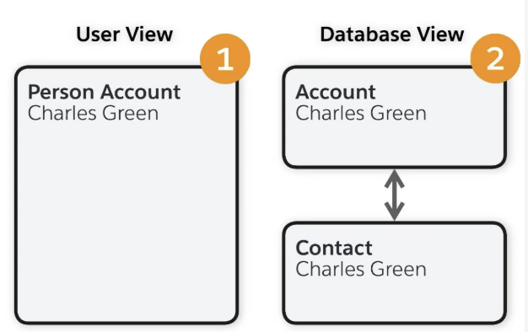
  - Person Account Model
In this example, the user view (1) shows a single record of a person called Charles Green. This record consolidates information from the account and contact records. However, behind the scenes, the database view (2) shows the record is actually an account and a contact with a 1-to-1 ratio, bi-directionally linked, representing a single person.

The Household Data Model
In the context of Health Cloud, the household data model maps the relationships between patients or members and the people and organizations who participate in their care. This map helps caregivers work more efficiently as they engage with the patient and provide them with the appropriate care.
The Account and Contact objects represent these caregivers and organizations. Business account records represent organizations. Person account or contact records represent people. A relationship type determines whether the relationship is between an organization and a person, two organizations, or two people.
The Account Contact Relationship, Account-Account Relationship, and Contact-Contact Relationship junction objects represent the relationship types. Junction objects are objects with two parent-child relationships that are the key to creating many-to-many relationships between objects. This means that one parent record can relate to many child records and each child can relate to many parent records. For example, a single account record can relate to many contact records, while a single contact record in turn can relate to many accounts.
Relationship Type | Description
Account Contact Relationship | A relationship between an account that represents an organization (or a household) and a person account or contact that represents a person.
Account-Account Relationship | A relationship between two business accounts or between a household and a business account.
Contact-Contact Relationship | A relationship between two contacts or two person accounts.

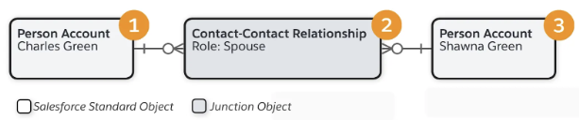
  - Example 1 – Person Account Contact Relationship
Charles’s person account record (1) has a contact-contact relationship (2) with Shawna’s person account record (3). The Role field adds further detail about the nature of each relationship, which in this example is Spouse.
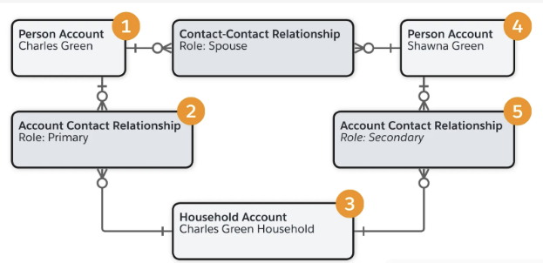
  - Example 2
Charles’s person account record (1) has an Account Contact relationship (2) with the Green household account record (3). Because Charles is the patient, he’s the primary contact for the household. Shawna’s person account record (4) also has an Account Contact relationship (5) with the Green household account record. Shawna is the secondary contact for the household.
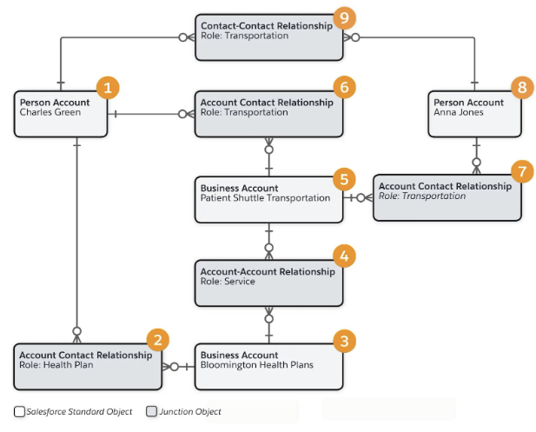
  - Example 2 – Household and Health Plan
Charles needs rides to his medical appointments. Charles has a health insurance plan with Bloomington Health Plans, which covers shuttle transport for patients as an insurance benefit. Patient Shuttle Transportation is an approved provider of this service. Anna Jones is an employee of Patient Shuttle Transportation. She’s a transportation coordinator who arranges rides to medical appointments for Charles.
Relationship Type | Example
Account Contact | - Charles’s person account (1) has an Account Contact relationship (2) with the Bloomington Health Plans business account (3).  - Patient Shuttle Transportation (5) has an Account Contact relationship (6) with Charles.  - Patient Shuttle Transportation has an Account Contact relationship (7) with Anna Jones (8), who is an employee.
Account-Account | Bloomington Health Plans has an account-account relationship (4) with the Patient Shuttle Transportation business account (5).
Contact-Contact | Charles has a contact-contact relationship (9) with Anna.

Clinical Data Model
A patient’s healthcare journey takes them to multiple providers and healthcare facilities at different times. To ensure the accuracy of patient medical records, Health Level Seven (HL7) defines industry-recognized standards for how healthcare providers structure, store, and transfer medical records. This ensures the systems that different providers and facilities use are interoperable. HL7 defines two standards for this purpose:
- Fast Health Interoperability Resources (FHIR)
- HL7
The Clinical data model aligns with FHIR and supports many of the HL7 message types. This data model captures information from an Electronic Health Record (EHR) system via integration middleware. It displays information commonly associated with EHRs such as patient or member encounters, chronic conditions, allergies, medications, and immunizations.

Clinical Encounters
The Clinical Encounter object represents a healthcare-related interaction between a patient and a care provider. Such an encounter occurs at any point of a patient’s healthcare service experience from pre-admission to stay to discharge.
A clinical encounter record includes fields with data such as the:
- Name of the patient who receives treatment
- Name of the person who provides care
- Facility where the encounter takes place
- Date and duration of the encounter
- Category and status of the encounter
- Admission source, and related encounter or appointment (if any)
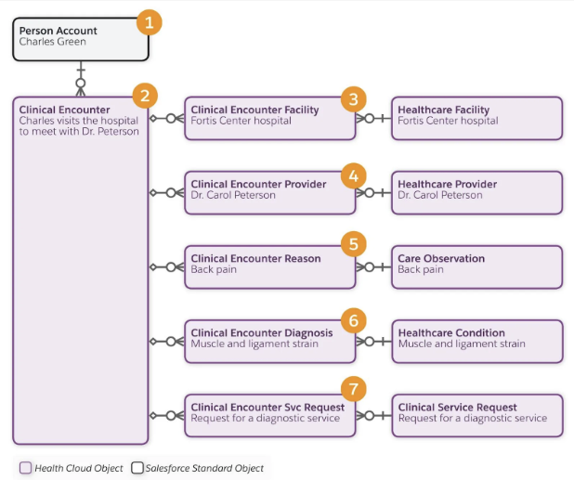
  - Example 3 - Clinical Encounter Journey
Related encounter objects add more detail to the encounter. These encounter records reference the clinical encounter record as the parent record, and reference records that exist outside of the encounter. Here's a summary of these objects and records.
Scenario Details | Object and Record Details
Charles Green is a patient. | Person Account (1)
Charles has a healthcare-related interaction with a healthcare provider. | Clinical Encounter (2)  A clinical encounter record references the patient’s person account record.
Charles visits the Fortis Center hospital. | Clinical Encounter Facility (3) specifies the healthcare facility where an encounter occurs.  A clinical encounter facility record references the parent clinical encounter and the healthcare facility record for Fortis Center hospital.  The Healthcare Facility object represents a healthcare facility and its physical, functional, geographic, or business details.
Charles meets with Dr. Carol Peterson. | Clinical Encounter Provider (4) specifies the provider involved in an encounter and the details of their involvement.  A clinical encounter provider record references the parent clinical encounter and the healthcare provider record for Dr. Peterson.  The Healthcare Provider object stores business-level details about a healthcare organization or person, such as the provider type.
Charles has a pain in his lower back. | Clinical Encounter Reason (5) specifies the reason why the encounter happened.  A clinical encounter reason record references the parent clinical encounter record and a care observation record.  The Care Observation object stores observations that a healthcare provider makes during a clinical encounter.
The diagnosis indicates that Charles is suffering from muscle and ligament strain. | Clinical Encounter Diagnosis (6) specifies a diagnosis related to a clinical encounter.  A clinical encounter diagnosis record references the parent clinical encounter record and the condition or procedure relevant to the encounter.  The Health Condition object represents a clinical condition problem, or any clinically relevant occurrence that is a matter of concern.
Dr. Peterson requests tests to confirm the extent of Charles’ injury. | Clinical Encounter Svc Request (7) specifies a request for a healthcare procedure or diagnostic service.  A clinical service request record references the parent clinical encounter record and the clinical service request record.  The Clinical Service Request object represents requests for a procedure or diagnostic service as part of the patient’s healthcare.

Diagnosis and Medications
The Medication object represents detailed information about medications. A Medication record includes data such as the:
- Name, category, and status of the medication
- Name of the organization that makes the medicine, and the code for the dosage form this medication is manufactured in
- Total amount or volume of the medication contained in the packaged product

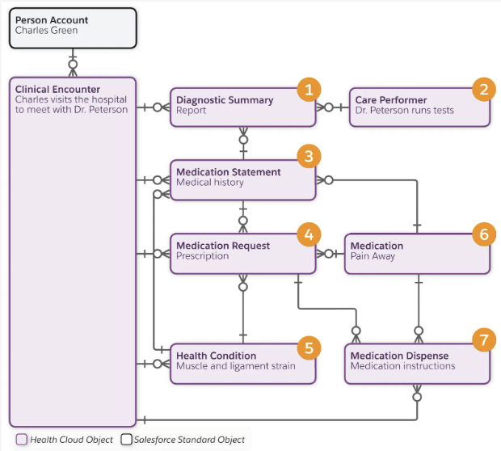
  - Example 4 – Diagnostic and Medications
Scenario Details | Object and Record Details
Charles receives his report. | Diagnostic Summary (1) represents the findings, interpretations, and summaries of tests performed on patients.  A diagnostic summary record references the clinical encounter record, a care performer record, and a medication statement record.
Dr. Peterson runs tests. | Care Performer (2) represents the person performing care in observations, procedures, and immunizations. This person may be a physician or anyone who administered care to the patient in the context of the care event.
Dr. Peterson reviews Charles’s medical history. | Medication Statement (3) represents a record of medication that the patient is currently taking or has taken in the past.  A medication statement record references the clinical encounter record and a medication request record.
Dr. Peterson prescribes new medicine for Charles. | Medication Request (4) represents a request or order for the supply of medication, along with information about how it should be administered.  A medication request record references the clinical encounter record, a medication record, and a health condition record (5).
Charles’s health condition is Muscle and ligament strain. | Health Condition (5)
Dr. Peterson specifies Pain-Away medication as the medicine to take. | Medication (6)
Dr. Peterson specifies the amount of medication to take. | Medication Dispense (7) represents the dispense of a medication to a patient in response to a medication request or order. This object also includes the instructions for how to administer the medication.  A medication dispense record references the clinical encounter record, a medication request record, and the medication record.

The Health Insurance and Claims Data Model
The Health Insurance and Claims data model provides objects for managing the ways healthcare is paid for. These objects represent information about members and their employers, insurance coverage, and dependents. This data model includes objects for claims submitted to a member’s health insurance company by an entity or person who provides a service, medication, or device to the member.
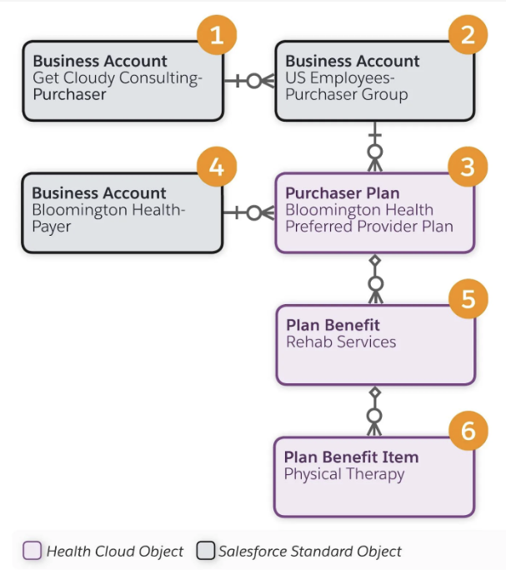
  - Example 5 – Health Insurance Data Model
Scenario Details | Object and Record Details
Get Cloudy Consulting is a global company that has purchased a health insurance plan for its US-based employees. | The Account object with a Business record type (1) represents the organization (purchaser) that purchases the health plan.  The Account object also represents purchaser groups that are subsets of the purchaser (2).  For example, an organization may have employee groups in different countries or different regions of a country. Each purchaser group can have separate options for insurance plans.  The account record for the purchaser group references the account record for the parent organization.
Bloomington Health Plans offers health insurance tailored to Get Cloudy Consulting for its US-based employees, such as a Preferred Provider Plan (PPO). | Purchaser Plan (3) represents the plan that a purchaser makes available to its members and members’ dependents.  A purchaser plan record references a purchaser or purchaser group record and the payer record.
Bloomington Health Plans is a payer organization that provides health insurance plans. | The Account object with a Business record type (4) represents the payer organization that helps cover the cost of member care.
Bloomington Health Plans offers Rehab Services as a benefit. | Plan Benefit (5) represents the standard benefits available under a plan that the purchaser offers to their members.  A plan benefit record references a purchaser plan record.
Bloomington Health Plans offers physical therapy visits as part of its Rehab Services benefit. | Plan Benefit Item (6) represents the details of a benefit.  A plan benefit item record references a plan benefit record.

Member Plans
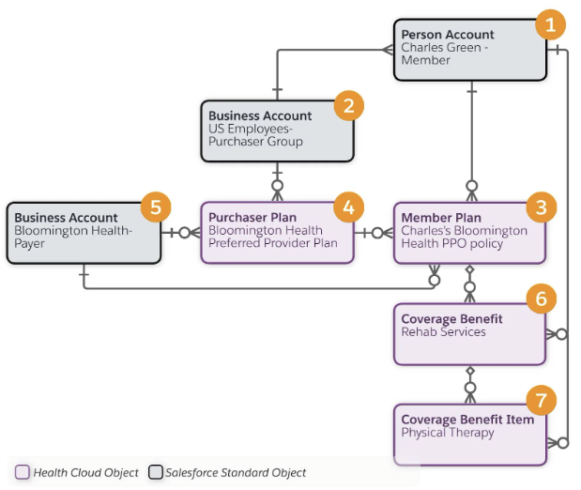
  - Example 6 – Members Plan
Scenario Details | Object and Record Details
Charles Green is a member who is covered under an insurance plan. | The Account object with a Person record type (1) represents a member.  A member has a relationship with the purchasing organization (2). For example, the member is an employee and the organization is their employer.
Charles enrolled in Bloomington Health Plan’s preferred provider plan (PPO). | Member Plan (3) represents details about the insurance coverage for a member.  A member plan record includes data such as the plan effective dates, the group number or policy number of the primary member, and the plan’s verification status.  A member plan record references a purchase plan record (4) and the payer organization (5).
As part of his policy, Charles is entitled to Rehabilitative Services. | Coverage Benefit (6) represents the coverage benefits that a member plan provides to a covered member.  A coverage benefit record includes data such as the benefit period start and end dates, the coverage type (Dental, Medical, Vision), and deductible limits.  Each coverage benefit has a benefit item.
This benefit includes up to 30 physical therapy visits per year. | Coverage Benefit Item (7) represents the specific services that a member plan covers.  A coverage benefit item record includes data such as the type of service it provides, and whether or not the service must be preauthorized before use.

Claims
Claims data resides outside Salesforce in a 3rd-party system. The Health Cloud claims functionality is delivered as an unmanaged package that contains a set of external Claim objects. External objects are objects that map to data that’s stored outside your Salesforce org. External objects enable your users to search and interact with the external data.
Before you install the Claims package, make sure your organization has a Salesforce Connect license. You need Salesforce Connect to set up the connection to your source system so that Health Cloud can pull your organization's claims data into the external objects. You need middleware to get this data from the 3rd-party claims systems.
In Setup, go to External Objects to view the claims objects and open them in Object Manager. You won’t see the objects if you search for them in Object Manager itself.
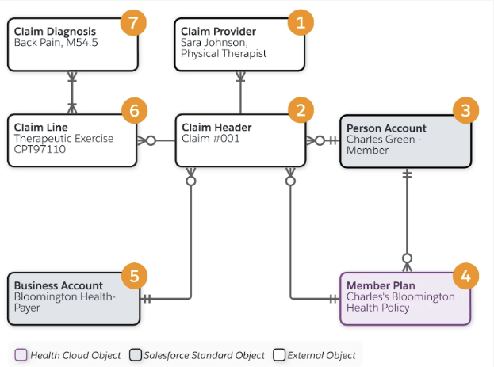
  - Example 7 – Claims
Scenario Details | Object and Record Details
Sara Johnson is the physical therapist who provides therapeutic exercises to Charles. | Claim Provider (1) represents information about a provider of a service, equipment or medication.
Sara files a claim for providing this service. | Claim Header (2) contains summary information about the claim, such as the payment amount, specified medications, and billing data.  A claim record references the provider who’s submitting the claim (1), and the member (3), member plan (4), and payer organization (5).  Claim Line represents a line item in a claim record (6). In this example, the claim is for the Therapeutic Exercises that Sara provided.  A claim line record references a claim diagnosis record.
The therapeutic exercises are to help Charles with his back pain. | Claim Diagnosis (7) represents the clinical diagnosis for which the service, equipment, or medication was provided. In this example, Back Pain is the diagnosis.

The Care Program Data Model
Healthcare and life science organizations provide care programs to support patients on their health journeys. Their goal is to increase adherence to care plans, encourage wellness practices, and provide financial help. Care programs cover services such as patient outreach, access to care and medications, financial assistance, and fitness and wellness plans. The Care Program data model helps you capture those activities so you can use Health Cloud to plan and track them better.
Note that a care program is different from a care plan. A care plan helps the healthcare team coordinate care more efficiently for a patient with the goal of improving the patient’s health. You can link a care program to a care plan.

Care Program Enrolments and Goals
The Care Program object represents a set of activities, such as a patient therapy, financial assistance, education, wellness, or fitness plan, offered to participants by an employer or insurer. It includes data such as the parent care program and program sponsor, approved budget, and program start and end dates.
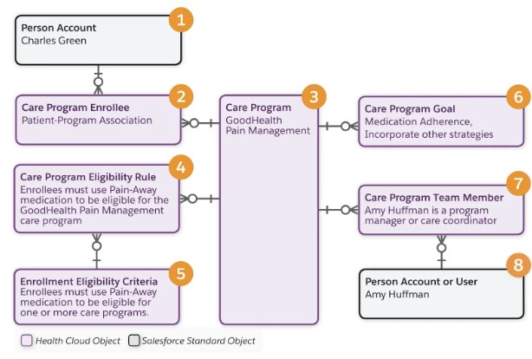
  - Example 8 – Health Care Program
Scenario Details | Object and Record Details
Charles Green is the patient. | The Account object with a Person record type (1) represents a patient.
Charles Green enrolls in the GoodHealth Pain Management care program. | Care Program Enrollee (2) represents a participant enrolled in a care program (3).  A care program enrollee record references the care program record and the participant’s person account record.
Charles is eligible for the GoodHealth Pain Management care program because he uses Pain-Away medication. | Care Program Eligibility Rule (4) represents a rule that defines the criteria for patient care program enrollment eligibility. For example, enrollees must use Pain-Away medication to be eligible for the GoodHealth Pain Management care program.  Enrollment Eligibility Criteria (5) represents criteria that defines patient enrollment eligibility for one or more care programs.  For example, enrollees must use Pain-Away medication to be eligible for one or more care programs.  A care program eligibility rule record references the care program record and an enrollment eligibility criteria record.  Business Rules Engine (BRE) determines eligibility based on the criteria that are set up.
The GoodHealth Pain Management care program has these goals.  - Adhere to Pain-Away medication  - Incorporate additional (non pharmacological) strategies | Care Program Goal (6) represents a business or clinical goal related to a care program. It includes data such as a detailed description of the goal, and its priority or sequence order relative to other goals.  Care program goal records reference the care program record.
Amy Huffman is a care coordinator for the GoodHealth Pain Management care program. | Care Program Team Member (7) represents a person who delivers services under a program, such as a program manager or care coordinator.  A care program team member record references the care program record and a person account or a user record (8).

Care Program Products

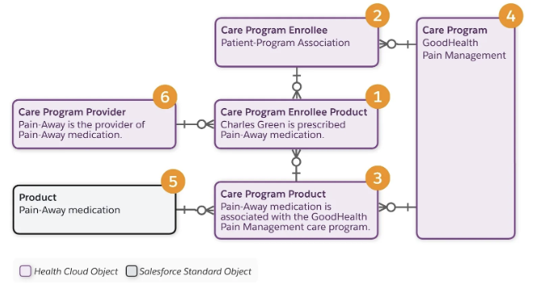
  - Example 9 – Health Care Program Products
Scenario Details | Object and Record Details
Charles Green is prescribed Pain-Away medication. | Care Program Enrollee Product (1) represents the affiliation between a care program enrollee (2) and a care program product (3).  A care program enrollee product record references the care program enrollee, the care program product, and the care program provider (6) records.
Pain-Away medication is associated with the GoodHealth Pain Management care program. | Care Program Product (3) represents the affiliation between a care program (4) and a product (5). Product is a Salesforce standard object for products that organizations sell.  A care program product record references the care program and the product records.
Pain-Away medication is provided by Pain-Away. | Care Program Provider (6) represents a business account that is the service provider for a care program product.  A care program provider record references a business account and a care program product record.

Care Program Campaigns and Surveys
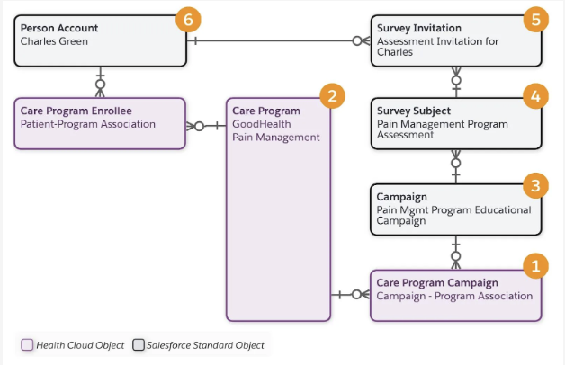
  - Example 10 –Program Campaigns and Surveys
Scenario Details | Object and Record Details
The GoodHealth Pain Management care program is running an educational campaign about using alternative pain management strategies. | Care Program Campaign (1) represents a relationship between the Care Program (2) and Campaign objects (3).  A care program campaign record references the care program and the campaign records.
The care program has a goal to provide education about alternative pain management strategies. | Campaign (3) is a Salesforce standard object that represents a marketing campaign such as a webinar.
The care program includes a pain management assessment survey. | Survey Subject(4) is a Salesforce standard object that represents the association between a survey Invitation and the campaign.
An invitation is sent to Charles Green to complete the assessment survey. | Survey Invitation (5) is a Salesforce standard object that represents the invitation sent to a participant (6) to complete the survey.  A survey invitation record references the participant record.

Social Determinants of Health Data Model
Social determinants of health (SDOH) are the critical social and environmental factors that may become barriers to a patient’s or member’s wellness. The Social Determinants data model helps you gain insight into the physical environment and socioeconomic status of a patient so that you gain a holistic perspective on these factors. This helps you identify intervention tasks to address care barriers and reduce health setbacks for patients and members.

Care Determinants
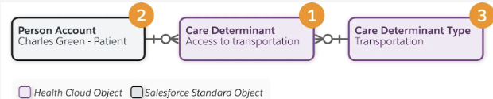
  - Example 11 – Care Determinant
Scenario Details | Object and Record Details
Access to transportation is a social determinant of health. | Care Determinant (1) represents the social determinants of health for a patient such as availability of safe housing, adequate employment, transportation, or local food markets.  A care determinant record references the patient record (2) and a care determinant type record (3).
Transportation is a care determinant type. | Care Determinant Type (3) represents a library of standard, predefined determinants that an organization maintains. For example, predefined care determinants include Income and Housing.

Care Barriers
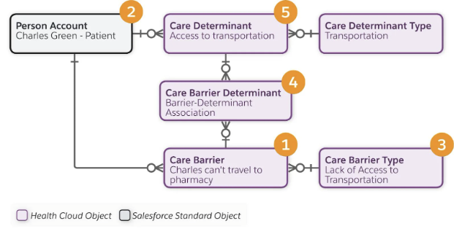
  - Example 12 – Care Barriers

Scenario Details | Object and Record Details
Charles doesn’t have a car and he can’t pick up his prescriptions on time. | Care Barrier (1) represents the circumstances or obstacles affecting a patient or member such as lack of housing, employment, transportation, or access to food.  A care barrier record references the patient record (2) and a care barrier type record (3).
Lack of transportation is a care barrier type. | Care Barrier Type (3) represents a library of standard, predefined barriers that an organization maintains. For example, predefined care barriers include Low income and Lack of Housing.
Lack of transportation is considered a care barrier to the access to transportation determinant. | Care Barrier Determinant (4) represents the relationship of a care barrier (1) to a care determinant (5). For example, a patient's lack of transportation is a care barrier that relates to the Transportation care determinant.  A care barrier determinant record references a care determinant record and a care barrier record.

Care Interventions
The care program team logs a case to address Charles’s transportation issue. To resolve the case, the team’s task is to find a transportation service.
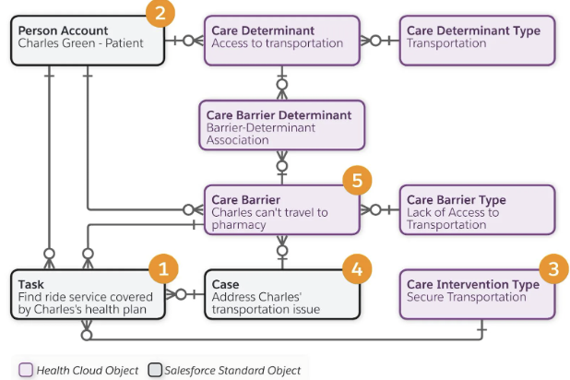
  - Example 13 – Care Interventions
Scenario Details | Object and Record Details
The team must find a transportation service covered by Charles’s plan with Bloomington Health Plans, his health insurance payer. | Task (1) represents the efforts made by the team to resolve case barriers.  A task record references the patient record (2), a care intervention type record (3), a case record (4), and a care barrier record (5).
Find transportation is a care intervention type. | Care Intervention Type (3) represents the standard, defined list of interventions that an organization maintains. For example, Find Transportation is an intervention type for the Lack of transportation care barrier.
The Good Health Pharma care program team logs a case to address Charles’s transportation issue. | Case (4) represents a patient issue or problem.

The Provider Data Model
The Provider data model represents healthcare providers, including individual practitioners and facilities, the network they participate in, and their specialties and credentials.

Healthcare Providers
When you model healthcare providers in Health Cloud, represent them as a person or an organization, and represent what they do.
The Account object with a Business record type represents providers that are organizations.

People
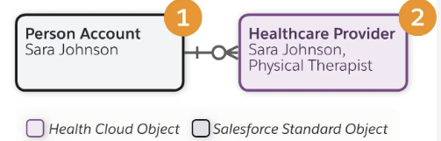
  - Example 14 – Health Care Provider Relationship

Organizations
A business account record (1) represents PT Health Specialists as an organization and a healthcare provider record (2) represents what this organization does. In the UI, the healthcare provider record references the business account in the Account field.
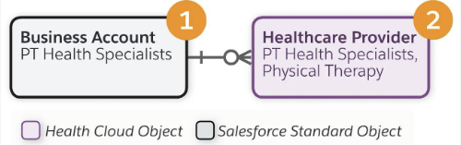
  - Example 15 – Health Care Provider Organisation Relationship

Healthcare Facilities and Facility Practitioners
Think of a healthcare facility as a building and a healthcare facility practitioner as a person who works in that building. The building has many people who work there, and a practitioner may work in more than one building. The next two objects cover these scenarios: Healthcare Facility and Healthcare Practitioner Facility.

Healthcare Facilities
The Healthcare Facility object represents a healthcare facility and its physical, functional, geographic, or business details. A healthcare organization’s local branches or facilities need healthcare facility records that reference a business account and a healthcare provider record for that specific branch or facility.
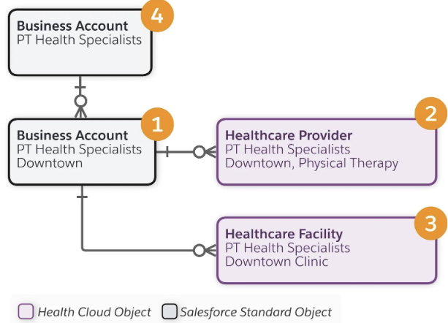
  - Example 16 – Health Care Providers and Facilities
A business account record represents the PT Health Specialists Downtown branch (1). The business account record references:
- A healthcare provider record for PT Health Specialists Downtown (2)
- A healthcare facility record for PT Health Specialists Downtown (3)
- The business account record for the parent business account (4)

Healthcare Practitioner Facilities
The Healthcare Practitioner Facility object represents the set of services that a practitioner provides at a specific location.
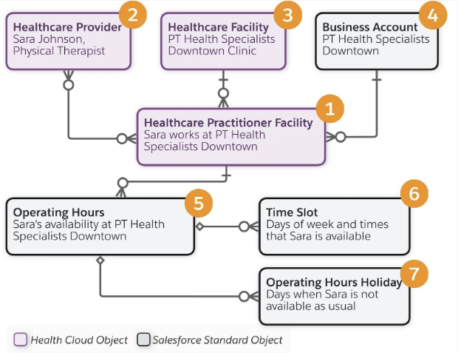
  - Example 17 – Health Care Practitioners Facilities
Scenario Details | Object and Record Details
Sara works at the PT Health Specialists Downtown branch. | Healthcare Practitioner Facility  The healthcare practitioner facility record (1) references:  - Sara’s healthcare provider record (2)  - The PT Health Specialists Downtown branch’s healthcare facility record (3)  - The PT Health Specialists Downtown branch’s business account record (4)  - An Operating Hours record that shows the hours that Sara is available (5)
Sara works from 9 AM to 5 PM on Mondays, Wednesdays, and Fridays. | Operating Hours (5) represents the hours that a person or organization is available to work.  An operating hours record references time slot (6) and operating hours holiday (7) records.  Time Slot (6) represents a range of time on a specified day of the week during which Sara performs her work. Operating hours consist of one or more time slot records.
Sara is not available on national holidays in the US such as Memorial Day and Labor Day. | Operating Hours Holiday (7) represents the days that Sara is not available at the usual time; for example, on national holidays.

Healthcare Payer and Facility Networks
To represent the payer network that a healthcare provider is affiliated with, two objects come into play: Healthcare Facility Network and Healthcare Payer Network.
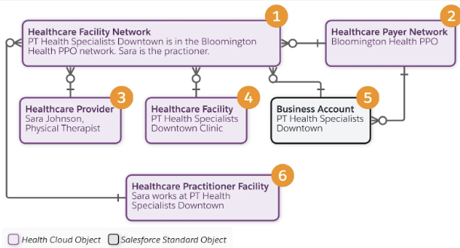
  - Example 18 – Health Care Payers and Network
Scenario Details | Object and Record Details
PT Health Specialists Downtown and Sara are in the Bloomington Health Plans PPO payer network. | Healthcare Facility Network (1) identifies the payer network that a location or business entity is a part of.  A healthcare facility network record references:  - The Bloomington Health Plans PPO healthcare payer record (2)  - Sara’s healthcare provider record (3)  - The Downtown branch's facility record (4) and business account record (5)  - The practitioner facility record that shows Sara works at the Downtown branch (6)
Bloomington Health Plans is the insurer that provides a PPO option for the network. | Healthcare Payer Network (2) represents an insurance network group. This object includes the type of network, such as HMO, PPO, or EPO.

Healthcare Provider Specialties
A healthcare provider can have multiple specialties and subspecialties. To represent them, Health Cloud has several care specialty objects.
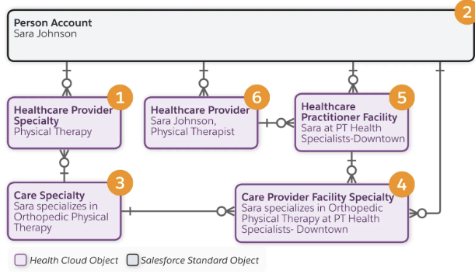
  - Example 19 – Health Care Provider Specialists
Scenario Details | Object and Record Details
Sara specializes in orthopedic physical therapy. | Healthcare Provider Specialty (1) represents specialties for a practitioner or a provider organization. Sara specializes in orthopedic physical therapy but she may have other specialties such as oncology or neurology physical therapy, each of which require different records.  Sara’s healthcare provider specialty record references:  - Her person account record (2)  - The orthopedic physical therapy care specialty record (3)  Care Specialty (3) stores provider specialty codes and descriptions.
Sara specializes in orthopedic physical therapy at PH Health Specialists Downtown. | Care Provider Facility Specialty (4) represents all the specialties that the practitioner provides at a given location.  Sara specializes in orthopedic physical therapy at PH Health Specialists Downtown but she may specialize in oncological physical therapy on different days at this facility. Therefore, she may have two care provider facility specialty records related to PT Health Specialists Downtown.  Sara’s care provider facility specialty record references:  - Her person account record (2)  - The orthopedic physical therapy care specialty record (3)  - Sara’s healthcare practitioner facility record for PT Health Specialists Downtown (5), which in turn references her healthcare provider record (6)

Healthcare Provider Certification, Education, and Licenses
Health Cloud has objects that represent a practitioner’s certifications, education, and licenses. These objects relate to either or both of the Person Account and Healthcare Provider objects.
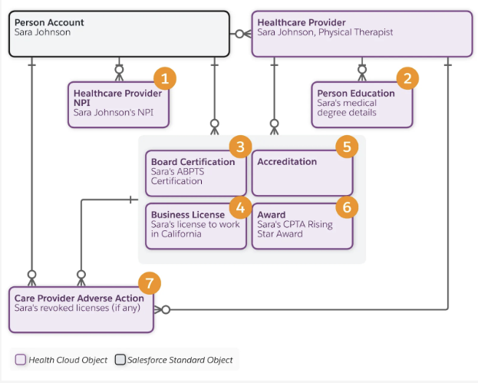
  - Example 19 – Health Care Certifications and Education
Scenario Details | Object and Record Details
Sara has a National Provider Identifier (NPI). | Healthcare Provider NPI (1) represents the National Provider Identifier assigned to every facility and licensed practitioner in the United States.  Sara’s NPI record references her person account record.
Sara has a medical degree. | Person Education (2) stores professional education details for a person in a provider role.  Sara’s education record references her healthcare provider record.
Sara is a board-certified Clinical Specialist in Orthopaedic Physical Therapy. | Board Certification (3) stores a practitioner's board certifications, which demonstrate the practitioner has undergone extra training to become a specialist or learn the latest advancements in their speciality.
Sara has a business license to work in California. | Business License (4) stores the licenses of a party role like healthcare provider or producer.
Not Applicable to this scenario. | Accreditation (5) represents the professional accreditations of a facility. For example, a joint commission accredits a facility as a general acute care hospital.
Sara is a recent winner of the California Physical Therapist Association (CPTA) Rising Star award. | Award (6) stores a person's or organization's professional awards.
Sara doesn’t have a record of any revoked licenses or other disciplinary actions. | Care Provider Adverse Action (7) captures adverse actions against the provider, such as malpractice lawsuits or revoked licenses.

Utilization Management Data Model
Utilization Management (UM) is the use of managed care techniques such as prior authorization to allow payers to manage the cost of health care benefits by assessing a benefit’s appropriateness before it’s provided, using evidence-based criteria or guidelines. UM ensures that patients receive the right care, at the right time, for the appropriate duration, in the right setting.
In Health Cloud’s Utilization Management, OmniStudio components combine to provide a guided user interaction for users who manage authorization request submissions and reviews. OmniScripts are available to create and submit an authorization request, conduct admin, nurse, and medical director reviews of the authorization request, and conduct peer-to-peer reviews with the requesting provider.
Business Rules Engine components streamline approval processes, simplify complex lookups, and automate business decisions in the authorization request workflows.
The UM data model aligns with FHIR R4 for interoperability and integration with external systems. UM includes APIs and integration applications deployed on MuleSoft for uninterrupted request processing with external Electronic Health Record (EHR) and payer systems. These APIs align with the FHIR Da Vinci Health Record Exchange (HRex) implementation guide.

Care Requests
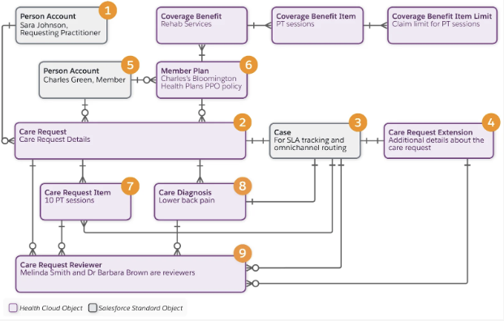
  - Example 20 – Utilization Care Request
Scenario Details | Object and Record Details
Sara Johnson is the practitioner who requests a preauthorization | The Account object with a Person record type (1) represents the requesting practitioner and servicing practitioner. The requesting and servicing practitioners can be different people but in this example, Sara is doing it all.
Sara Johnson submits a preauthorization request. | Care Request (2) represents the general details of a care-related request. Care requests include preauthorizations for drugs and services, admission notifications, and concurrent reviews of admissions. A single request can contain multiple diagnoses and services.
Sara’s preauthorization request generates a case record. | Case (3) represents the case record for the preauthorization. This object allows for setting up SLA tracking based on milestones and entitlements, and omnichannel routing for workflow management.
Sara’s preauthorization request includes additional details related to the member’s health plan. | Care Request Extension (4) represents extra details for a care request such as subscriber details for the member's health plan.
Charles is the member who needs care. | The Account object with a Person record type (5) represents Charles Green as a member.
Charles subscribes to the Bloomington Health Plans PPO member plan, which includes benefits for rehab services. | Member Plan (6) represents the member plan. This object relates to the Coverage Benefit, Coverage Benefit Item, and Coverage Benefit Item Limit objects, which store the benefit details related to Charles’s member plan.
Sara’s request includes 10 physical therapy sessions in the request details. | Care Request Item (7) represents the details of a care service request.
Sara refers to lower back pain as the diagnosis of Charles’ health condition. | Care Diagnosis (8) represents the details of a diagnosis including code type, name, and description.
Melinda Smith and Dr. Barbara Brown review the care request. | Care Request Reviewer (9) represents the details of a care request reviewer including name, reviewer type, status of the care request at the end of the review, the reviewer’s notes, and date of review.

